Here is our experimental setup. We have the actual quadrupole trap connected to a voltage step up transformer that is powered from a variac. We maximize the variac at 35V which is stepped up by the 115:12000-ratio transformer. We use two glass slides to strip electrons from dust particles as they fall into the trap.

A laser light is used to illuminate the dust particles in the trap.

Figure 1 shows our setup. The quadrupole trap has 4 poles that oscillate charge based on an AC voltage (60Hz). When charged dust particles fall into the trap, tend to oscillate in ‘needles’ and ‘boxes.’ The needles are perpendicular to the poles and perpendicular to gravity. The boxes are two dimensional squares that are perpendicular to the poles.

We have also constructed a C++ program using a fourth order Runge Kutta method to model the paths of different conditions. We are attempting to use this program to find the stable paths of the trapped dust particles

We also are going to use a 1000 fps camera to image the paths. Our first attempt failed just using the camera. Some lensing and tripod will be necessary to record the paths.

For future use of this setup, a CCD camera coupled with a shutter box could be used for imaging the paths at slower frame rates.

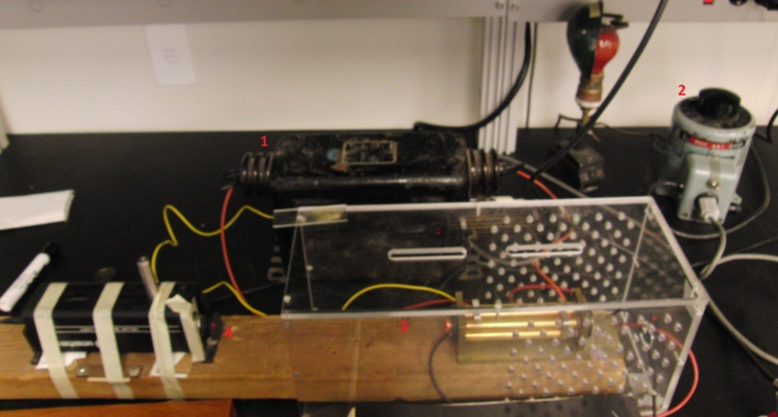

Figure 1 – 1) Transformer. 2) Variac. 3) Quadrupole Trap 4) Laser for illlumination

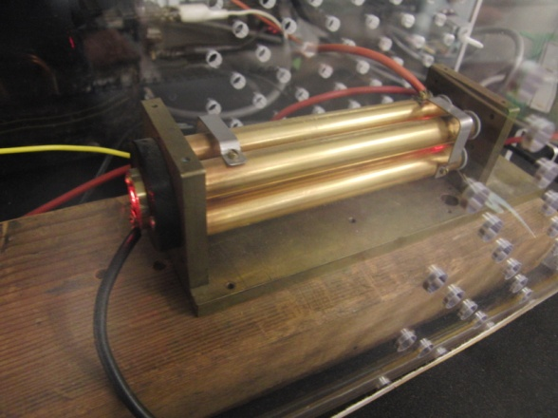

Figure 2- close up of quardrupoles

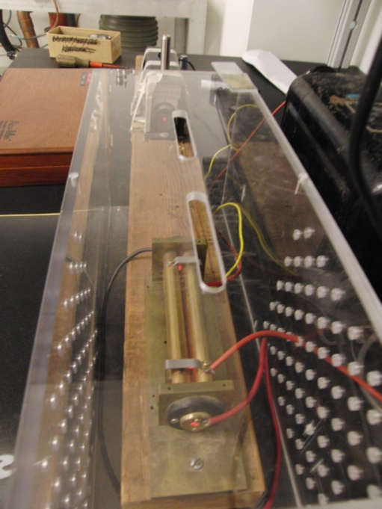

Figure 3 – laser aligned with quadrupole inside Plexiglas case to stop air flow.